GAURAV SINGH Contact No.: +91  9454943464 E-Mail: gaurav8singhgs@gmail.com

To work in a globally competitive environment on challenging assignments that shall yield the twin benefits of the job satisfaction and a steady paced professional growth. Id love to prove my value & show how I can adopt to new tasks , processes and increased responsibilities.

Preferred Functional Areas: FRONT OFFICE

Personal Details
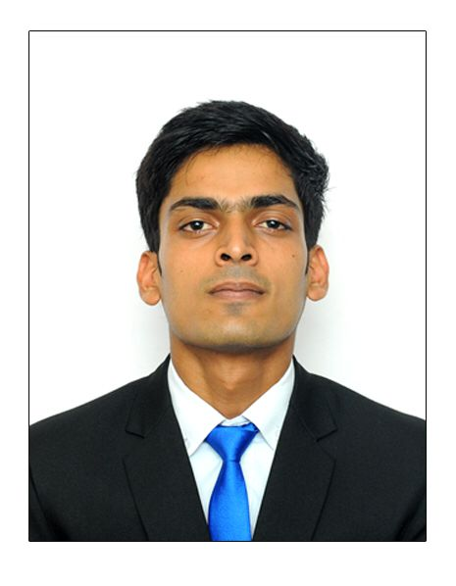
- Date of Birth : 08 0ctober 1997
- Fathers Name : Mr. Gulab Singh
- Mothers Name : Mrs. Usha Singh
- Language Known : Hindi & English
- Gender : Male
- Nationality Indian
- Permanent Address Sec 14/511/2 Indira Nagar,
Lucknow , 226016

Work exposure

- Currently working with MARRIOTT INTERNATIONAL, GURGOAN,HARYANA as Sales Service Associate(10 months) .
- Duties and responsibilities were Register & process guests and their assigned rooms.
- Up Selling guest rooms and promoting hotel services.
- Handling guest accounting details
- Supply guests with information regarding property amenities, services, room features .
- Ensure adherence to quality expectations and standards
- Contact appropriate individual or department as necessary to resolve guest requests
- Handling guest call maintaining front office daily record's.
- Expert level in (PMS) worked on ids, marsha .

Industrial Exposure

- 17 Weeks of Industrial Training from The Piccadily Lucknow

Key Skills

- Able to work in a intense time and volume constrained environment

- Ability to stay calm under pressure.

- Organised and detail Oriented.

- Able to work flexible schedule.

Education

- 2017-18 2nd Year of IHM GOA(59.28%)

- 2016-17 1nd Year of IHM GOA (59.28%)

- 2015-16 Intermediate from NIOS ,Lucknow.

- 2013-14 High school from CBSE Board .

Computer Skills

- Microsoft office (Word , Excel , Power point ) & opera, micros, Marsha & empower.

Language Known

- Hindi - Mother tongue
- English - Fluent

Interests

- Passionate cricketer and footballer.
- Indoor games like table tennis.
- Travelling
- Exploring new places & Music.

I hereby declare that the above information given by me is authentic and best of my knowledge.

LUCKNOW GAURAV SINGH

