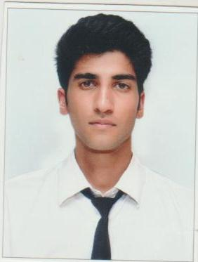
CURRICULUM VITAE

ABHISHEK
Vill Biddi Po Darwar, Tehsil Sarkaghat, Distt Mandi HP
Mobile: +9309851954 E-mail: abbuthakur393@gmail.com
INDUSTRIAL TRAINING

- I have successfully completed 6 months Industrial Training at RADISSION BLU RESORT GOA CAVELOSSIM BEACH. (From 4th Sept 2017 to 24th Feb 2018)
During this period I have been trained in the following departments:-
Food Production.

Responsibilities

- Prepare the daily mis-en-place and food production in different sections of the main kitchen or satellites
- Coordinate and participate with other sections of requirements & cleanliness.
- Prepare ingredients for cooking, including portioning, chopping, and storing food before use
- Inspect the cleanliness and working condition of all tools, equipment and supplies, ensure everything complies with standards.
- Set up station and on time for each service period
- Registration of guest and assiginig rooms.
- Greeting costumers, escorting them to seat taking food & drink order, serving food & beverages

PROFESSIONAL QUALIFICATION
Diploma in Cooking from National Finishing & Cookery Institute, Solan (Himachal Pradesh)

PERSONAL DETAILS

First Name & Surname : ABHISHEK
Date of Birth : 06th April 1999
Gender : Male
Marital Status : Single
Nationality : Indian
Languages Known : Hindi & English.

Date:
Place: (Abhishek)

